The Silent Struggles: Understanding Anxiety, Stress, and Self-Esteem in Teens
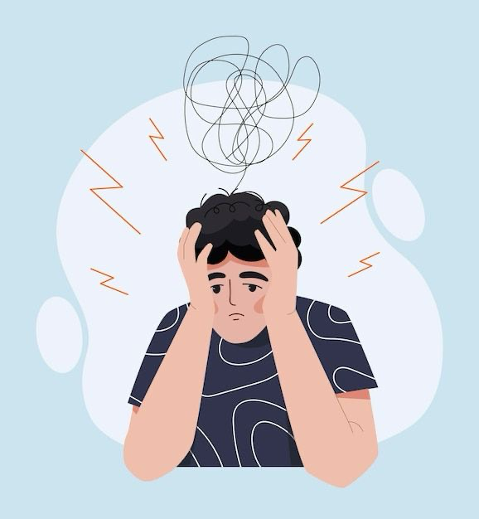

Welcome back to the Ikigai Teen blog, where we decode the teenage mind to help parents raise emotionally strong, value-centered young adults in this fast-changing world.
Today, we’re diving into one of the most quietly painful realities of modern adolescence: the silent struggles of anxiety, stress, and low self-esteem. If you've ever asked your teen how they are and heard, "I'm fine, Mom," but their eyes told a completely different story, this article is for you.

The Hidden Epidemic We Can No Longer Ignore
Just a few years ago, the world was united against a global pandemic that impacted every aspect of our lives. But as we navigated that crisis, a parallel epidemic was intensifying in the shadows, one that continues to rob families of joy and nations of their future citizens. I’m talking about the crisis in youth mental health—an epidemic that is not so hidden if we just pause and look around.
The numbers are stark and speak for themselves:
- A 2023 UNICEF India report found that 1 in 7 Indian adolescents experiences symptoms of anxiety or depression.
- Nearly half of Indian teens surveyed by the Fortis Mental Health Network said they often feel “overwhelmed by expectations.”
- Globally, the WHO confirms that suicide is the fourth leading cause of death among 15 to 19-year-olds.
And yet, most parents never hear a word about this inner turmoil. Why? Because today’s teens have become masters at masking pain with performance. They post smiling selfies, share their achievements, and laugh at memes. But inside, many are drowning in a sea of self-doubt, comparison, and a pervasive fear of not being “enough.”

What’s Really Going On Inside Their Minds?
To help our teens, we first need to understand what they're experiencing. The teenage brain is still under construction, especially the prefrontal cortex—the area responsible for logic, emotional control, and future-thinking. This means that when they face criticism or life feels chaotic, they experience these emotions far more intensely than an adult would.
Now, add these modern pressures into the mix:
- Social Media Comparison: A constant, curated feed showing them that “everyone’s doing better than me.”
- Academic Expectations: An unrelenting pressure to succeed, where the fear is, “I can’t afford to fall behind.”
- Parental Approval: The silent question, “Will they still be proud of me if I fail?”
- Peer Validation: The deep, primal need to answer, “Do I belong?”
Each of these becomes a silent trigger, creating a looping cycle of anxiety that often manifests as irritability, withdrawal, extreme perfectionism, or a complete shutdown from overwhelm. We sometimes misread these signs as laziness or defiance, but beneath the surface, they are often a cry for emotional safety.
Teen anxiety rarely shouts. It’s a pain that hides in plain sight.
Furthermore, self-esteem in teens today is more externally dependent than ever before. Their sense of worth is often tied to metrics that can shift by the hour—views, grades, and comments. How can anyone keep up? It's no wonder they are exhausted.

Shifting Our Perspective with a Touch of Humor
Let’s be honest. If you’ve ever looked at your teen and said, “Why are you so stressed? You have food, Wi-Fi, and an AC!”—welcome to every parent’s club in India.
But here’s the crucial insight: their world is different from the one we grew up in, but their pain is just as real. Digital peace of mind can feel like emotional survival to them. We need to meet them where they are—not by minimizing or trivializing their reality, but by mirroring it with empathy. Much of the learning and adapting lies with us as the adults in their lives.

How Parents Can Help Build a Bridge
So, what can we actually do to help? Here are five mindful steps to transform the emotional climate at home:
- Name the Emotion, Don't Dismiss It: Instead of saying, “Stop overreacting,” try, “I can see that you’re really upset.” Simply naming the emotion helps calm the amygdala, the brain’s alarm center.
- Create a Calm Corner: This isn’t a punishment zone, but a dedicated comfort space. It can be a small corner with soft lighting, a comfortable chair, plants, or a journal. It signals that it's okay to retreat and recharge.
- Model Healthy Self-Care: Teens learn emotional regulation through observation. When they see you managing your own stress with awareness—whether it’s through exercise, meditation, or a hobby—they learn that it’s possible to navigate pressure constructively.
- Praise Effort, Not Just the Outcome: Shift your language from, “Why didn’t you score higher?” to “I love how you kept trying, even when it was difficult.” This detaches their self-worth from their performance.
- Listen Without Lecturing: This is perhaps the hardest, yet most powerful, tool. Sometimes, all your teen needs is for you to hear them out without jumping in with solutions or advice. Your silent, focused presence can heal more than your words ever could.
Parenting teens in this era isn’t easy. But it’s not easy for them, either. They are growing up in a noisy world where everyone has an opinion, but very few people listen deeply. Let’s start by being that one safe space where they feel heard without fear.
As I often say, “Children grow calm not when the world gets easier, but when they feel seen and heard.”
Every effort we invest in them today will see them growing stronger, brighter, and ready for a world that only becomes more complex by the day.

